Night

By Elie Wiesel

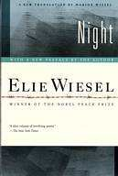

STUDENT NAME:
TEACHER’S NAME: ____________________ ENGLISH 10 PERIOD

Night By Elie Wiesel
Assignments Chart

 | Packet Check Dates | Assignments Due | Score
1 | Friday, 4/6 | - Night Forward written response, pg. 5  - Holocaust WebQuest, pg. 8-9
2 | Friday, 4/13 | - Methods of Dehumanizing notes and response, pg. 11  - First 2 entries on Motifs chart, pg. 10
3 | Friday, 4/20 | - Born Good video notes and response, pg. 12-13  - 2 more entries on Motifs chart, pg. 10
4 | Friday, 4/27 | - Bystander Effect Notes and Response, pg. 15  - Upstander Notes and Response, pg. 16  - 2 more entries on Motifs chart, pg. 10
5 | Friday, 5/4 | - Assault on History, pg. 17  - Theme Chart, pg. 15  - Final 2 entries on Motifs chart, pg. 10

Introduction: About World War II

World War II killed more people, involved more nations, and cost more money than any other war in history. Altogether, 70 million people served in the armed forces during the war and 17 million combatants died. Civilian deaths were even greater. At least 19 million Soviet civilians, 10 million Chinese, and 6 million European Jews lost their lives during the war.
World War II was truly a global war. Some 70 nations took part in the conflict, and fighting took place on the continents of Africa, Asia, and Europe, as well as on the high seas. Entire societies participated, as soldiers, war workers, or victims of occupation and mass murder.

Background:

World War II costs the United States a million casualties and nearly 400,000 deaths. In both domestic and foreign affairs, its consequences were far-reaching. It ended the Depression, brought millions of married women into the workforce, initiated sweeping changes in the lives of the nation’s minority groups, and

Excerpt from Forward to Night, by Elie Wiezel

CONVINCED THAT THIS PERIOD in history would be judged one day, I knew that I must bear witness. I also knew that, while I had many things to say, I did not have the words to say them. Painfully aware of my limitations, I watched helplessly as language became an obstacle.

It became clear that it would be necessary to invent a new language. But how was one to rehabilitate and transform words betrayed and perverted by the enemy? Hunger—thirst—fear—transport—selection—fire—chimney: these words all have intrinsic meaning, but in those times, they meant something else. Writing in my mother tongue—at that point close to extinction—I would pause at every sentence, and start over and over again.

I would conjure up other verbs, other images, other silent cries. It still was not right. But what exactly was "it"? "It" was something elusive, darkly shrouded for fear of being usurped, profaned. All the dictionary had to offer seemed meager, pale, lifeless. Was there a way to describe the last journey in sealed cattle cars, the last voyage toward the unknown? Or the discovery of a demented and glacial universe where to be inhuman was human, where disciplined, educated men in uniform came to kill, and innocent children and weary old men came to die? Or the countless separations on a single fiery night, the tearing apart of entire families, entire communities? Or, incredibly, the vanishing of a beautiful, well-behaved little Jewish girl with golden hair and a sad smile, murdered with her mother the very night of their arrival? How was one to speak of them without trembling and a heart broken for all eternity?

Deep down, the witness knew then, as he does now, that his testimony would not be received. After all, it deals with an event that sprang from the darkest zone of man. Only those who experienced Auschwitz know what it was. Others will never know.

But would they at least understand?

Could men and women who consider it normal to assist the weak, to heal the sick, to protect small children, and to respect the wisdom of their elders understand what happened there? Would they be able to comprehend how, within that cursed universe, the masters tortured the weak and massacred the children, the sick, and the old?

And yet, having lived through this experience, one could not keep silent no matter how difficult, if not impossible, it was to speak.

For the survivor who chooses to testify, it is clear: his duty is to bear witness for the dead and for the living. He has no right to deprive future generations of a past that belongs to our collective memory. To forget would be not only dangerous but offensive; to forget the dead would be akin to killing them a second time.

Sometimes I am asked if I know "the response to Auschwitz"; I answer that not only do I not know it, but that I don't even know if a tragedy of this magnitude has a response. What I do know is that there is "response" in responsibility. When we speak of this era of evil and darkness, so close and yet so distant, "responsibility" is the key word. The witness has forced himself to testify. For the youth of today, for the children who will be born tomorrow. He does not want his past to become their future.

Written Response
Based on what you read in Elie Wiesel’s forward to his memoir Night, what do you believe is the reason he wrote Night? What was his purpose in telling his story? What is he hoping to accomplish?
____________________________________________________________________________________________________________________________________________________________________________________________________________________________________________________________________________________________________________________________________________________________________________________________________________________________________________________________________________________________________________________________________________________________________________________________________________________________________________________________________________________________________________________________________________________________________________________________________________________________________________________________________________________________________________________________________________________________________________________________________________________________________________________________________________________________________________________________________________________________

Jewish Terms
Night Glossary

anti-Semitic: feelings or actions against Jews
Cabbala, Zohar: the system and the most important book of Jewish mysticism captivity of Babylon: when Jews had to leave ancient Israel to go to Babylonia Hasidic: an extremely orthodox and religious Jewish group
Inquisition: Church trials to make sure people were Christian- people who weren’t we burned alive.
Kaddish: Jewish prayer for the dead
Maimonides: famous Jewish thinker
Messiah: the future messenger from God who will announce peace in the world
Palestine: area of the Middle East which is now Israel and Jordan
phylacteries: objects used or morning prayers rabbi: Jewish religious leader
Rosh Hashanah: Jewish New Year
synagogue: a building where Jews go to pray
Temple: the ancient building in Jerusalem where all Jews prayed
Talmud: books written and studied to interpret the Bible
Yom Kippur: Day of Atonement (10 days after Rosh Hashanah)- a day of fasting and repentance
Zionism: idea of recreating a Jewish state

German Terms
Budapest: capital of Hungary
concentration camp: place where Jews were sent to be killed or to work as prisoners
(Auschwitz, Birkenau, Buchenwald, Buna)
crematory/ crematorium: rooms where Nazis forced Jews to go so that they could be killed by breathing poison gas (Jews were told they were taking showers)
Fascist: dictatorial government
Gestapo: Nazi police
ghetto: area where only one cultural, ethnic or religious group is permitted to live Kapo, Kagerkapo, Oberkapo: Jewish guards in the concentration camp and ghetto Nazi: German acronym or the National Socialist Party formed by Adolf Hitler
SS: Nazi soliders

Map of Some Concentration Camps

Key
[!]C..,tt.!City
"""-"-
0
0 ................"-
0 200 Kilometers
200Miles

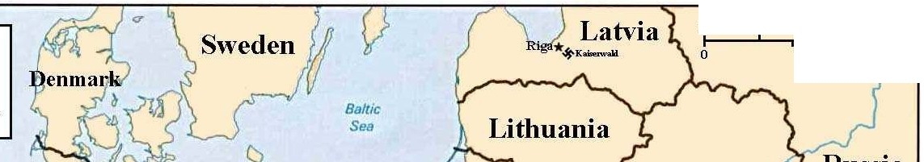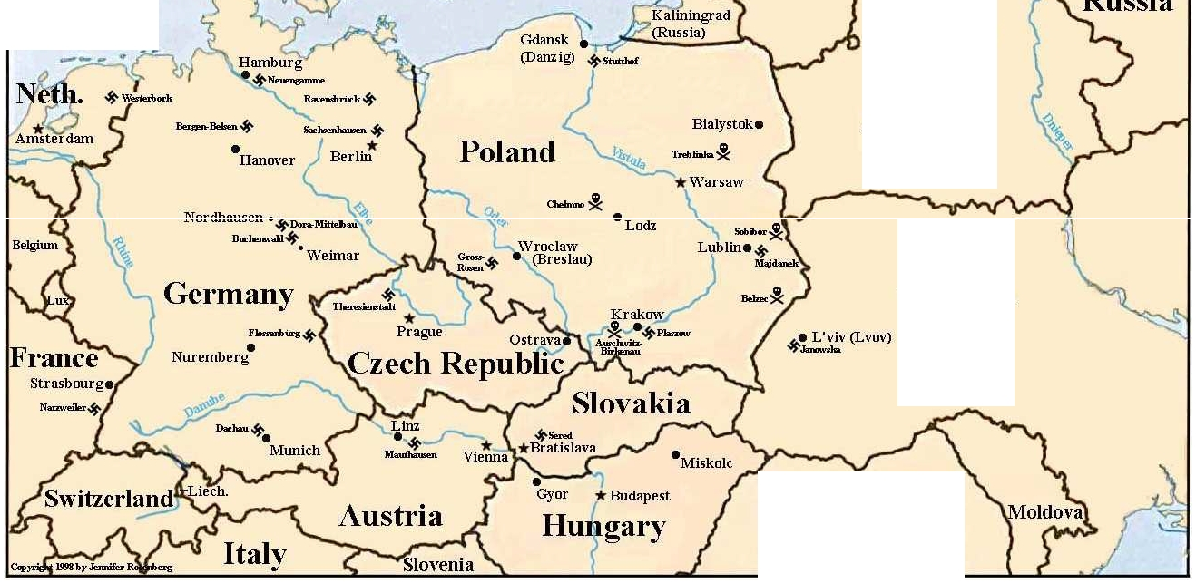

North
Seo Belarus

*Minsk

'*'Kolo!E"""'
•Baranovici

Ukraine

Romania

WebQuest
World War II: The Holocaust

In this WebQuest, you will learn what the Holocaust was, why and how it targeted certain people,

- Go to www.ushmm.org. Click on History. Click on Introduction to the Holocaust.

What is a “holocaust”?

What is the people group most widely targeted by the Holocaust during WWII?

Who else was targeted?

- Go to www.jewishvirtuallibrary.org/jsource/Holocaust/36quest1.html.
How long did the Holocaust last? From what year to what year?

How many Jews were killed? How many non-Jews were killed?

Which European country had the biggest percentage of their Jewish population murdered?

In April 1933, what were the rights or freedoms taken away from Jewish citizens to begin their destruction?

What was the “Final Solution” the Nazis came up with?

Scroll down to the bottom of the page and click on [19-29]. Question 21 addresses the Allied response to the migration of the Jews out of Europe. How did the United States meet the Jewish immigrants?

- Go to http://www.calvin.edu/academic/cas/gpa/catech.htm. This is a pamphlet used in many German schools. Answer the following questions about this.

What was taught as the characteristics of a German person?

How is a Jewish person painted in this pamphlet? What types of behavior does a Jew exhibit?

4. Go to http://www.history.co.uk/explore-history/ww2/genocide/photo-gallery.html. Look through the pictures and read the captions. Stop on the one captioned “Kristallnacht.”

What happened on the night of November 9, 1938?

Knowing what else you’ve read about in these captions of pictures, why would the Nazis mark Jewish-owned stores?

What are some words you’d use to describe the emotions the Jews probably felt on and after Kristallnacht.

Motifs Chart
Fill in throughout reading the memoir Night
Example of Silence, Apathy (Indifference) or Fear? | Description of the Event – Be specific and include page number | Consequence or result of character reaction?

Dehumanizing

Video title: 912 days of the Warsaw Ghetto
Watch the following video, taking note of how the Jewish people were treated by the Nazis and Nazi sympathizers.
Take at least FIVE notes during the course of the video.
1. __________________________________________________________________________________________
____________________________________________________________________________________________

2. __________________________________________________________________________________________
____________________________________________________________________________________________

3. __________________________________________________________________________________________
____________________________________________________________________________________________

4. __________________________________________________________________________________________
____________________________________________________________________________________________

5. __________________________________________________________________________________________
____________________________________________________________________________________________

How do the Germans/Nazis work to break the spirit or take away the hope of the Jews in the ghettos? Use both Night and notes form the video.
________________________________________________________________________________________________________________________________________________________________________________________________________________________________________________________________________________________________________________________________________________________________________________________________________________________________________________________________________________________________________________________________________________________________________________________________________________________________________________________________________________________________________________________________________________________________________________________________________________________________________________________________________________________________________________________________________________________________________________________________________________________________________________________________________________________________________________________________________________________________________

Born Good – 60 minutes
Prewrite – Consider an age old question: Are humans born good or bad, or do we learn right and wrong from our parents and society? Defend your answer with examples.

Directions: 60 Minutes reported on research that attempts to answer this question. Are humans born with an understanding of right and wrong, or are we taught these values? Watch the 60 Minutes “Born Good?” video segment and answer the following questions.
- How were researchers able to determine that babies know the difference between right and wrong, and how could they tell that babies have a sense of justice?

- Their findings seem to suggest that humans are born with an innate ability to understand and reinforce fairness and justice. Does this surprise you? Why or why not?
- How were researchers able to determine that babies show bias toward others? How might this discovery help explain certain behaviors in society?
- Karen Wyn talks about an “us and them” mentality. Where do you see examples of this (RBV, Vista, the US, the world)?

- Using context clues from the video, define the term bigot.
- Paul Bloom mentions that biased behavior is to be expected from creatures that are the result of natural selection. What does he mean when he says this? Explain is point in your own words.
- In the token game, where students choose how many tokens they receive, were you surprised by the behavior you saw in the younger children? Where you surprised by the behavior you saw in the older children? Why or why not? Do you agree with the researchers’ theory behind why the children’s behavior starts to change by age 8?
- Bloom argues that although we are taught generosity and kindness, stressful events can wipe those away and we return to our biases, but they also said that a stressful event can bring out heroism. Consider stressful events in our nation (9/11, election cycles, natural disasters, economic recessions). How do people show both of these sides during a stressful event?
Night is a memoir describing one boy’s real life experience during the holocaust. How does this video segment shed light on how and why bias and racial exists and how to address it?

Theme Chart
In this section, Wiesel is pushed closer and closer toward hopelessness and death. His inexplicable will
to live and the realities of life pull him back again and again. As you read, think about the events and emotions that influence Wiesel’s zigzag journey between death and life. In the chart below, record examples of events that create a sense of hopelessness and events that provide hope.

Hopelessness and Death Hope and Life

Bystander Effect Notes and Response
Summarize the Bystander Effect from the video:
____________________________________________________________________________________________________________________________________________________________________________________________________________________________________________________________________________________________________________________________________________________________________________________________________________________________________________________________________________________________________________

How does the Bystander Effect connect to the events portrayed in the memoir Night?
____________________________________________________________________________________________________________________________________________________________________________________________________________________________________________________________________________________________________________________________________________________________________________________________________________________________________________________________________________________________________________

Bystander and Upstander Notes
Directions: As you listen to stories of bystanders and upstanders during the Holocaust, record explanations for the choices made by individuals, groups, and nations in the chart below. Record any questions raised by these stories at the bottom of the page.
Reasons or Explanations for BYSTANDER behavior | Reasons or Explanations for UPSTANDER behavior

Questions:

Assault on History (pg 114-122)
Think of an issue you have a strong opinion about. Have you ever spoken out about it? What was the reaction of your audience? If you have never spoken out about it, why not? What prevented you? ____________________________________________________________________________________________________________________________________________________________________________________________________________________________________________________________________________________________________________________________________________________________________
Background
A small group of people believe that the Holocaust never happened and was merely a long-running Jewish “hoax.” Newsday staff writer Bob Keeler examines this group––self-proclaimed Holocaust revisionists––and its theories about the Holocaust.
Responding to the Reading
1. What does the American Historical Association say about the Holocaust? What do the revisionists say about the Holocaust? What do you think of this controversy?
______________________________________________________________________________________________________________________________________________________________________________________________________________________________________________________________________________________________________________________________________________________________________________________________________________________________________________________________________________________________________________________________________________________
2. The director of the United States Holocaust Research Institute says “good scholarship ultimately drives fraud from the marketplace.” What do you think this means? Explain why you agree or disagree. _________________________________________________________________________________________
_____________________________________________________________________________________________________________________________________________________________________________________________________________________________________________________________________________________________________________________________________________________________________________________________________________________________________________________________
3. How does the Committee for Open Debate attempt to spread its message on college campuses? Why does the committee target college students? _____________________________________________________________
____________________________________________________________________________________________________________________________________________________________________________________________________________________________________________________________________________________________________________________________________________________________________
4. What might Wiesel have to say to the revisionists? ______________________________________________
___________________________________________________________________________________________________________________________________________________________________________________________________________________________________________________________________________

